- Complete the text with the words given in the box.
- Write the main ideas of the text in appropriate Spanish.

- complex - tends - distance - significant - range - placement – develops – maximizes – acoustic – until –

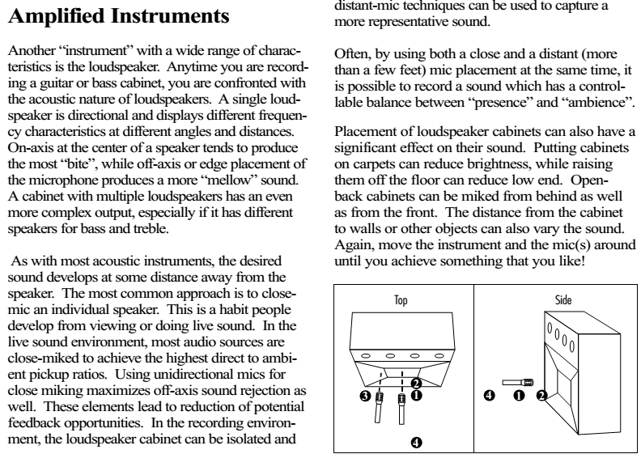

- Watch the following videos to increase the vocabulary and expressions related to the topic.
- https://www.youtube.com/watch?v=qXfOJ_-SBHY (first)
- https://www.youtube.com/watch?v=Mvaoe3XLDlY (second)

