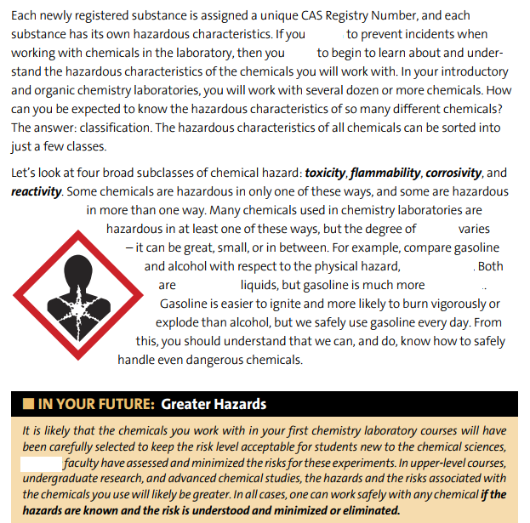
Exercises
- Complete the blanks with: hazard – hazardous – intend – flammable – flammability – need
- The answer to which question is: Classification. Why?
- Identify comparatives in the first text. Why is this structure used?
- Identify and analyze connectors in the first text.
- Identify and classify modal verbs in the first text.
- Is likely an adverb in the first text?
- IN YOUR FUTURE: which connector is better for the blank: consequently – however – because
- What is the condition and the consequence in the last sentence?
- Analyze sentences in passive voice. Which are the real subjects of them?
- Has likely got the same meaning and category (noun, adverb, adjective, verb) in the second text?

