**States of Matter**

**1. Read the following article. What is the meaning of the expressions in bold?**

There are four main states of matter: solids, liquids, gases and plasmas. Each of these states **is also known** as a phase. Elements and compounds can move from one phase to another phase when special physical forces are present. One example of **those forces** is temperature. The phase or state of matter can change when the temperature changes. Generally, as the temperature rises, matter moves to a more active state.

Phase describes a physical state of matter. The keyword to notice is physical. Things only move from one phase to another by physical means. If energy **is added** (like increasing the temperature or increasing pressure) or if energy **is taken away** (like freezing something or decreasing pressure) **you** have created a physical change.

One compound or element can move from phase to phase, but still be the same substance. **You** can see water vapor over a boiling pot of water. That vapor (or gas) can condense and become a drop of water. If **you** put that drop in the freezer, **it** would become a solid. No matter what phase **it** was in, **it** was always water. **It** always had the same chemical properties. On the other hand, a chemical change would change the way the water acted, eventually making **it** not water, but something completely new.

1. What is passive voice? Find examples of passivevoice in the above text.

2. What are the rules for transforming active sentences into passive?

**Forming passive sentences:**

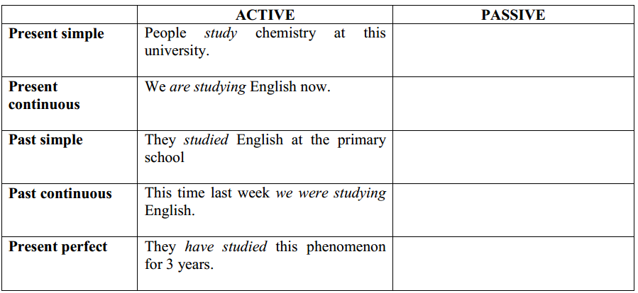

3. When do we use passive voice?

4. Compare the following 2 sentences. Why is the agent/doer not mentioned in the first one?

* This element is called hydrogen.
* Periodic Table was devised by Mendeleev.

5.When is it not necessary to mention the doer?

**Exercises:**

**Exercise 1 Transform these sentences into passiveor active voice.**

1. They make Rolls Royce cars in England.

2. Rice is grown in China.

3. The telephone was invented by Bell in 1876.

4. Thieves have stolen 2 pictures from the museumlast night.

5. The factory will produce 10,000 cars next year.

6. She was given this watch by her aunt.

7. British policemen don’t carry guns.

8. Periodic Table was devised by Mendeleev.

9. They will publish the news tomorrow.

10. They were doing this experiment yesterday at 9am.

**Exercise 2 Find passive sentences in the text and transform them into active.**

**The Fourth State of Matter**

There are three classic states of matter: solid, liquid, and gas; however, plasma is considered by some scientists to be the fourth state of matter. The plasma state is not related to blood plasma, the most common usage of the word; rather, the term has been used in physics since the 1920s to represent an ionized gas. Lightning is commonly seen as a form of plasma.

Plasma is found in both ordinary and exotic places.When an electric current is passed through neon gas, it produces both plasma and light. Lightning is a massive electrical discharge in the atmosphere that creates a jagged column of plasma. Part of a comet's streaming tail is plasma from gas ionized by sunlight and other unknown processes. The Sun isa 1.5-millionkilometer ball of plasma. It is heated by nuclear fusion.

Scientists study plasma for practical purposes. In an effort to harness fusion energy on Earth, physicists are studying devices that create and confine very hot plasmas in magnetic fields. In space, plasma processes are largely responsible for shielding Earth from cosmic radiation, and much of the Sun's influence on Earth occurs by energy transfer through the ionized layers of the upper atmosphere.