Discussing- Opportunities- Made- Between – Teaches- Screens - Is -Technology - New - Impossible- Most – Were – Made –Has - Time
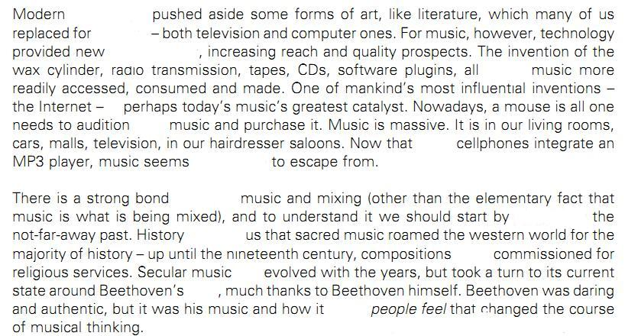

..................................................................................................................................................................................
1 Discussing-2 Opportunities- 3 Made- 4 Between –5 Teaches- 6 Screens - 7 Is -8 Technology -9 New – 10 Impossible- 11 Most –12 Were –13 Made –14 Has -15 Time

