UNVIERSIDAD NACIONAL DE QUILMES
INGLÉS I y II MÚSICA integrados - Examen Final
Nombre:……………………………………………………Legajo:…………………………………………..Fecha:……………………
- Read the text and solve the activities below .
- Complete the blanks with the words given.20p
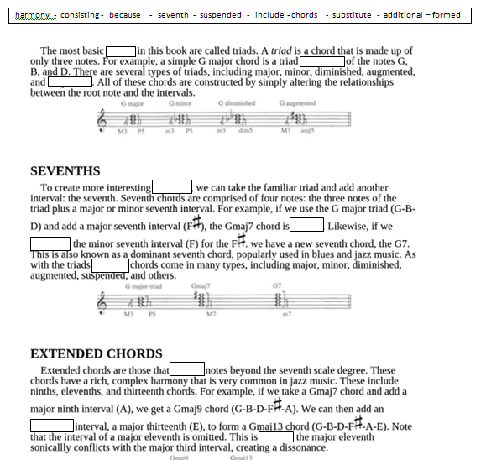
- Write the references for:9p
This:..................................................................................................................
These:...............................................................................................................
This:.................................................................................................................
- Write the function of:9p
by:......................................................................................................
or:..............................................................................................
as:..............................................................................................
- Explain the function of the following modal verb in the sentences it appears:5p

Can: ..............................................................................................

- Identify one expression of comparative and superlative in the text.5p

- Identify one sentence in passive voice and explain it.5p

- Choose either “Sevenths” or “Extended Chords” section and write it in appropriate Spanish.5p
- Listen and complete the tasks bellow:

- What’s the topic of the audio?4p...........................................................................................

- What comparison is mentioned as regards the topic?4p......................................................

- Why is the topic important in the West?4p...........................................................................

- Which periods are mentioned?4p..........................................................................................

- Complete the following paragraph from the audio (20p):
We have it in …………………………... We have it in history. We have it in the …………………………... Why do we have it? It's simply a ………………………………. established after the fact that allows us to …………………………….. material in ways that we can grapple with it, ways that we can ……………………………………… it. So in music what has happened is that we have organized this ………………………………………… stream of …………………………. in ways that we can understand. We organize them. We …………………………………. these into units of two, for example, …………………………………..of two like this, or we have an ………………………………………………stream like this.
- Write the last paragraph into appropriate Spanish 6p
UNVIERSIDAD NACIONAL DE QUILMES
INGLÉS II MÚSICA - Examen Final
Nombre:……………………………………………………Legajo:…………………………………………..Fecha:…………………………….

- Complete the blanks with the words given 30p.

- Wrte a summary of the text in appropriate Spanish 20p

- Listen and complete the tasks bellow:

- What’s the topic of the audio?5p...........................................................................................

- What comparison is mentioned as regards the topic?5p......................................................

- Why is the topic important in the West?5p...........................................................................

- Which periods are mentioned?5p..........................................................................................

- Complete the following paragraph from the audio (20p):

We have it in …………………………... We have it in history. We have it in the …………………………... Why do we have it? It's simply a ………………………………. established after the fact that allows us to …………………………….. material in ways that we can grapple with it, ways that we can ……………………………………… it. So in music what has happened is that we have organized this ………………………………………… stream of …………………………. in ways that we can understand. We organize them. We …………………………………. these into units of two, for example, …………………………………..of two like this, or we have an ………………………………………………stream like this.

- Write the last paragraph into appropriate Spanish 10p

