Activity 1: Complete the blanks with the words given

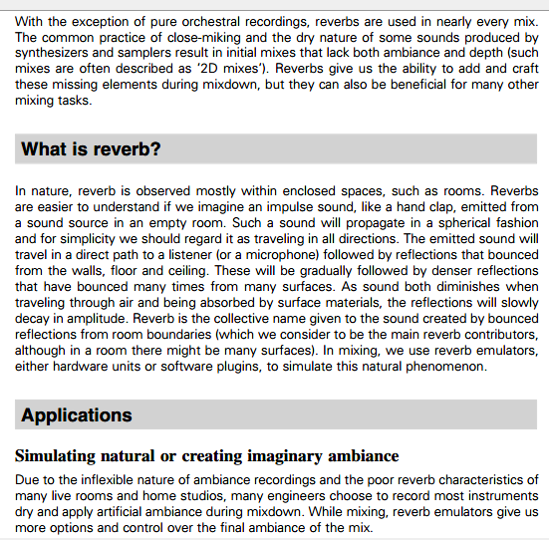
final - direct - inflexible - observed - reverbs - absorved - practice – emitted - units
Actividad 2: Escribir en castellano como leería las siguientes palabras del texto:
Miking: ……………………………………………………………………………………………..
Missing:……………………………………………………………………………………..……..
Mixing:…………………….………………………………………………………………………..
Traveling x 2:………………………………………………………………………………………

