Unit 24 Task 2

I’d like to begin the …......................... by giving you a very basic overview of the programming ….............................. We’ll then move on to the details. So, to write a …..................................., we normally follow these steps.
A program usually provides a solution to a given …................................... For example, how to …............................... wages and income tax in a big company. First of all, you have to ….............................. exactly what the problem is and define it …........................... This means you have to decide in a general way how to …............................... the problem. The next step is to design a step by step plan of …................................... This usually takes the form of a flow chart, a ….................................... that uses special symbols to show how the ….................................. works through the program, where it makes decisions, where it starts and ends, where data is …................................., things like that. Next you write the instructions in a …................................. language like Basic, Pascal or C. These computer instructions are called ….................................. Then you have to use a …..............................., a special program that converts the source code into …......................................, the only language understood by the …........................................which consists of ones and ceros.
Once you’ve written the program, you have to ….............................. it with sample data to see if there are any ….............................. or errors. The process of correcting these errors is called …............................... Computer programmers have to find the …................................. of each error, write the correct instructions, compile the program again and test it until it works …..............................
Finally, you have to write program …....................................., a detailed description of how to use the program. A great program is not much good if …......................................... don’t know how to use it.
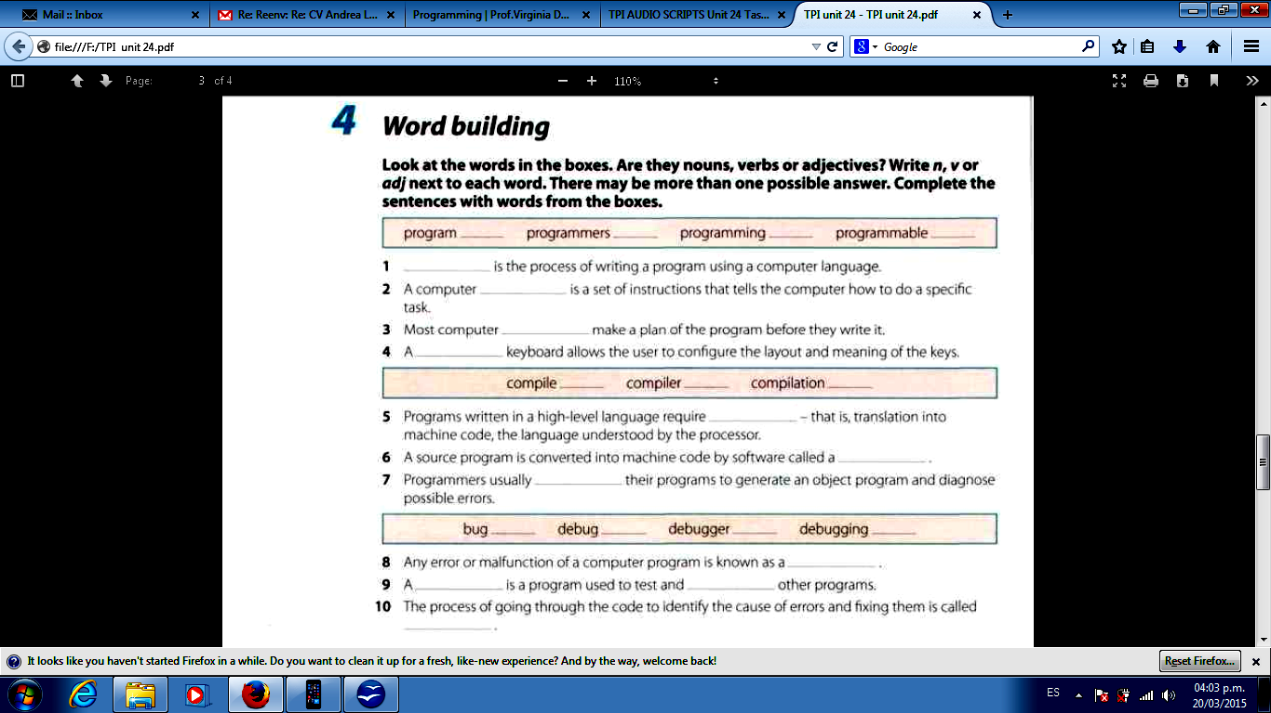
- Identify verb tenses.

- Identify sentences in passive voice.

- Classify words ending in -ed and -ing.

- Identify modal verbs and their functions.

- Identify connectors and their functions.

