UNIVERSIDAD NACIONAL DE QUILMES
INGLES - EXAMEN PACIAL - 1ER CUAT.2016
Nombre y mail:................................................................... Legajo:.................. Fecha:......................

- Listen to the following audio. Answer the questions in Spanish or English.
- Then complete the blanks and write the paragraph in appropriate Spanish
- Identify the topic of the audio:…………………………………………………………………………………………………..…………………
…………………………………………………………………………………………………………………………………………………………………..
- What is the purpse of the topic mentioned: ………………………………………………………………….………………………………
…………………………………………………………………………………………………………………………………………………………………..
- Write the 7 operations in the order mentioned by the audio: …………………………………….………………………………..
…………………………………………………………………………………………………………………………………………………………………..
- Write the numbers , the combination of letter-number and the formula:…………………………………………………….
…………………………………………………………………………………………………………………………………………………………………..
- You can also update the information in different …………………………….. by linking cells. This means that when you make a ………………………………………….. in one worksheet, the same change is made in the other worksheet. The ……………………………………. menú in a spreadsheet usually includes several commands you …………………………………………….to choose the font, number allingment, borders, …………………………………………… width and so on. Most spreadsheet programs can also ………………………………………….. graphic representations. The values of cells are shown in different …………………………………………..: such as line graphs, bars or pie-charts. They are given three dimensional …………………………………………. Some spreadsheet programs also have a data base ………………………………………….. which transforms the values of cells into a database. In this case each colun is a ……………………………………….. and each row is a record.

- Reply to the following mail you have received.
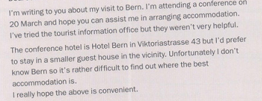

- Complete the text with the words given and then write the main information in appropriate Spanish
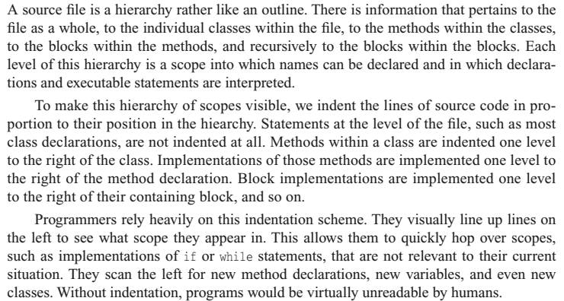

level -recursively -scheme- unreadable -declaration - executable -implementations- hierarchy – position - methods

