Universidad Nacional de Quilmes - Inglés II para Música – Modelo de Parcial

Actividad 1: Listen, answer and complete the blanks.

- What is the topic of the audio?

- Which examples are mentioned which are taken from studies?

If you want to see an example of the healing …………………… of music, then watch the video below about Henry, an old man who has been living in a nursing home for 10 years. Like some people his age, Henry is suffering from …………………….. He forgets things easily and has lost many of his mental abilities. In fact, Henry lives in his own world, often unresponsive to other people. But the nurses ……………………………… that if they let him listen to his favorite music from the past, he is instantly transformed with life energy, and suddenly able to have ………………………….. with the people around him. Music breathes life into his body and mind. It truly is an amazing example of the healing power of music.

Actividad 2: Read and complete the blanks with the given words. Then, write it in appropriate Spanish.
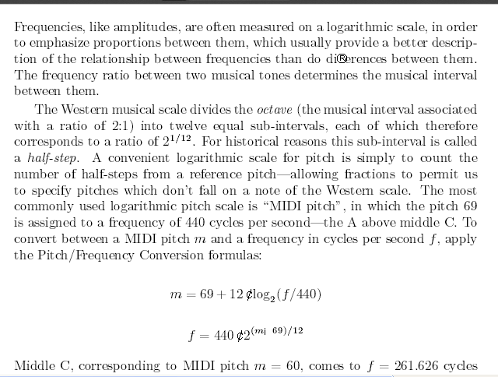
don’t fall - divides - tones - differences - corresponds - logarithmic - relationship - is called -
frequencies – permit - is assigned – apply

