UNIVERSIDAD NACIONAL DE QUILMES INGLES II Modelo de Parcial 2016
Listen to the following audios, then write the in appropriate Spanish
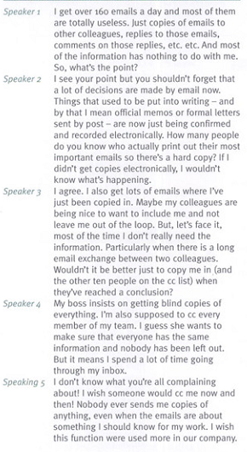
NAME: ………………………………………………………………………………………
Reply to the following mail you have received.


Complete the text with the words given and then write the main information in appropriate Spanish
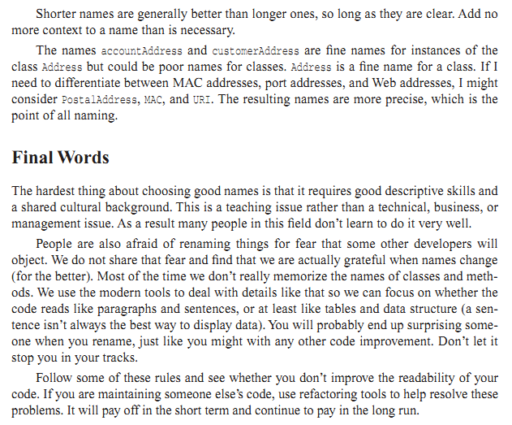

hardest - addresses - maintaining - paragraph - people - could - clear - necessary - naming - grateful – might -

