- Read the text, solve the activities below and write it in appropriate Spanish

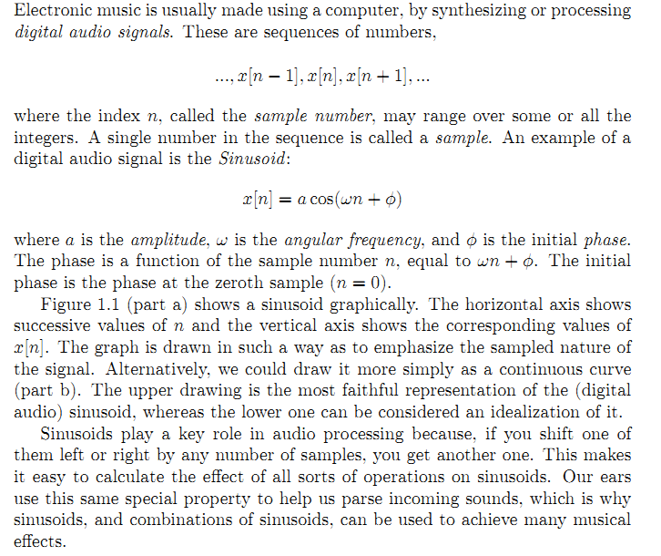

- Write the references for:

It:....................................................................................................................

It:....................................................................................................................

This:.................................................................................................................

Us:....................................................................................................................

- Write the function of:

Or:......................................................................................................

Whereas:..............................................................................................

Beacuse:..............................................................................................

- Explain the function of the following modal verbs in the sentences they appear:

May:...........................................................

Could:.........................................................

Can: ..........................................................

- Read and complete the blanks with a word from the list. Then, write in appropriate Spanish what you understand.
developed - highlighted - to visualize - will group - can observe - experiment
