vduchEnfermería:
- Welcome to English 1 – hi hello / good morning afternoon evening/
Farwell : good bye / bye bye/ see you later next week

- Introductions: My name is…./ I am…+ name/ occupation: I am the nurse : ners

- Course information (day, time, material, resources, syllabus)

- Celia Nieto pag. 7-10 + exercises

- Word category: noun verb – adjective – articles – prepositions – conjunctions

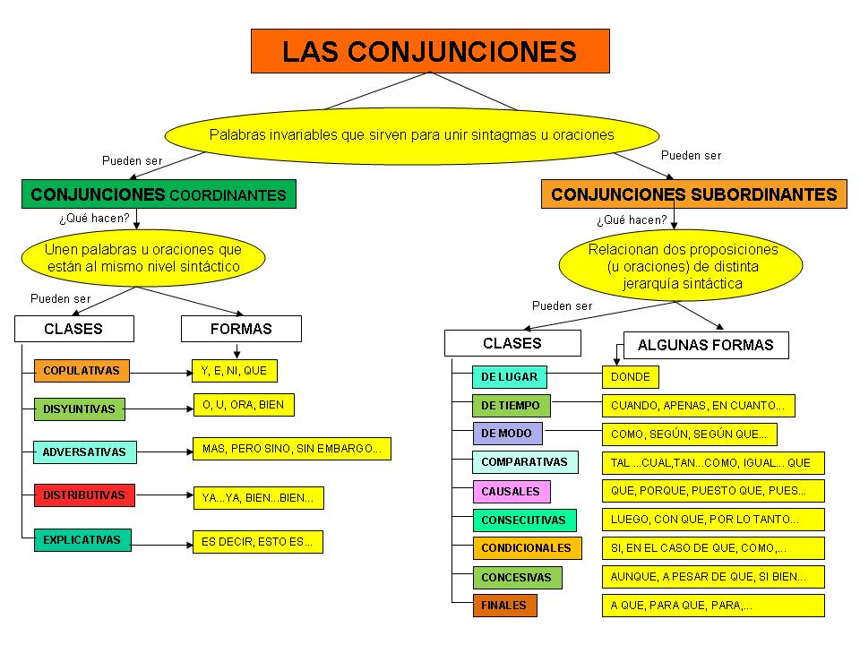
- The language of medicine 12 pages
- The anatomy coloring book 16 pages
- Palabras transparentes o cognados
My students are intelligent
Present
Introduce – introduction
Teacher
Book – room - blood - floor

