Virginia Duch
vduch@unq.edu.ar
virginiaduch.blog.unq.edu.ar
lunes de 14 a 16
5 trabajos prácticos aprobados – no parcial/ parcial integrador
Oralidad a desarrollar en clase – 80% de asistencia –
Saludar:
Hello/Hi (informal)/ Good morning/ afternoon/ evening (formal depending on the moment of the day)
Good bye/ good night see you later (lo veo luego) tomorrow
See you tomorrow morning
my name is ……. and I am the nurse on duty (de turno)
Hello my name is Maria and I'm the neonatology nurse
Off duty: de franco = day off
What/When is your day off?= When are you off duty?
I/ you have a temperature/fever/
I have a pain in + part of the body = my arm aches/hurts (part of the body)
I have a stomachache
I am worried = estoy preocupada
http://kidshealth.org/
as + adjective+ as means equivalent
tan grande/ caro/difícil como
my house is as small as a tent (=carpa)
shape: forma
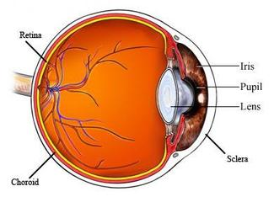
It rains.
Why don’t you calm down and tell me what happens?
Tell me what you feel please?
Do you feel better? Worse?

