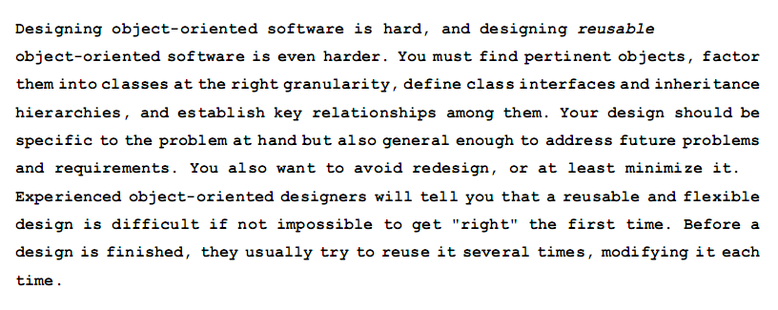
- among - interfaces - finished- design - classes - problem – software – designers – address – modifying –

EXERCISES ON THE TEXT:

- Complete the blanks with a suitable word from de box.

- Analyse verb tenses.

- Identify at one sentence in passive voice.

- Identify modal verbs and state their function in the sentence.

- Identify one comparative.

- Analyze words ending in –ing, -ed and –s and establish their grammatical category.

- Identify references and their corresponding referents.

- Write the text in an coherent way in Spanish.

SOURCE:
