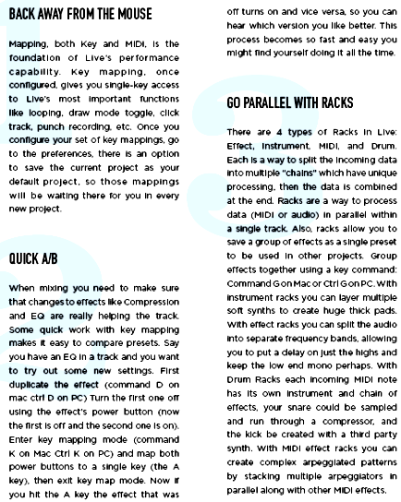

version - changes - preferentes - used -sampled - compare – types - project - looping- effect – foundation - mapping - data - create - keep - racks

