UNIVERSIDAD NACIONAL DE QUILMES

PROGRAMACIÓN INFORMÁTICA

INGLES II EXAMEN PARCIAL

Comisión:...........................Nombre:................................................................Fecha:......................

- Listen to the audio, complete the blanks and write what you understand in appropriate Spanish.

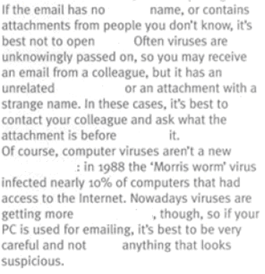

- Identify three words ending in –s and establish their category or write the Spanish equivalent.

- Write the reference for: them (line 16), it (line 21), your (line 30)

- Read the text and complete with words from the box below. Then write it down in appropriate Spanish.

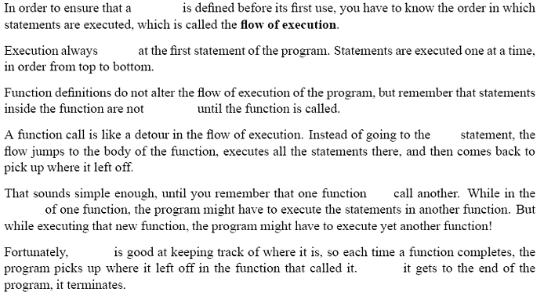

can - function - Python - begins - next - executed - when - middle -

- Identify and explain one sentence in passive voice from this text.

- Identify and explain one modal verb.

- You have received a mail from a colleague. The body of his/her mail is the following:

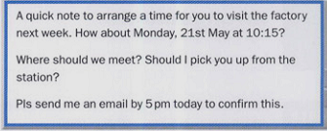

- Write an appropriate response to your colleague

