Can I take a message for you?

No thank you, I’ll call back later./ I’ll try his/her mobile/cell

Can I leave a message for him?

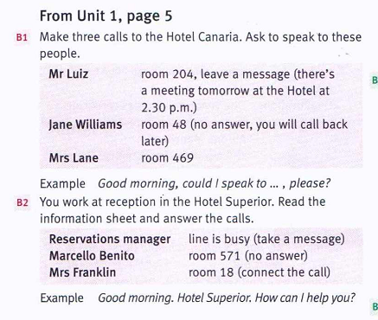

There is one shop.

There are more than 900 rooms.

There aren’t/ there isn’t

Is there ….are there…..???

At the top/ at the bottom/ at the front/ at the back/ on the right /on the left/ in the middle

plate

Type of menu:

A la carte/ list of prices for each dish

Table d’hote menu is a price which includes at least three courses (starter, main dish and dessert)

International cuisine

Cocktail bar

Set the table/ clear the table

leftovers

is there internet acces?

Yes there are.

Home made food/dish

Is there a car park in the hotel?

How many rooms are there in the hotel?

What facilities are there in the hotel?

Has the hotel got swimming pool?

Does the hotel offer/have/provide….?

The hotel has/offers/provides….

What about money? Can I change money in the hotel?

Can I park my car?