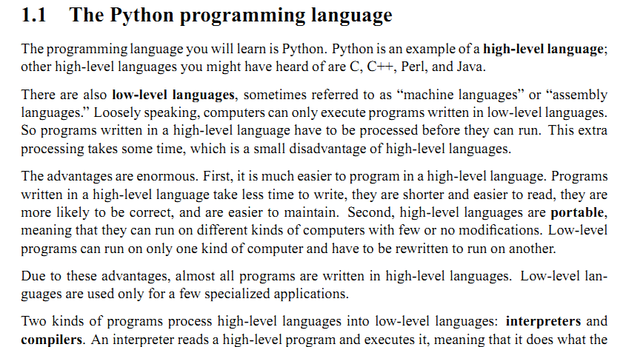 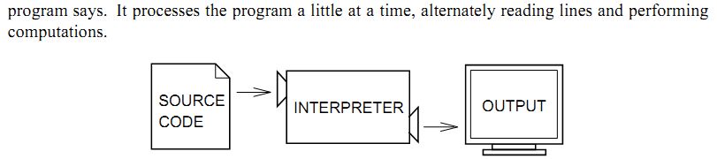

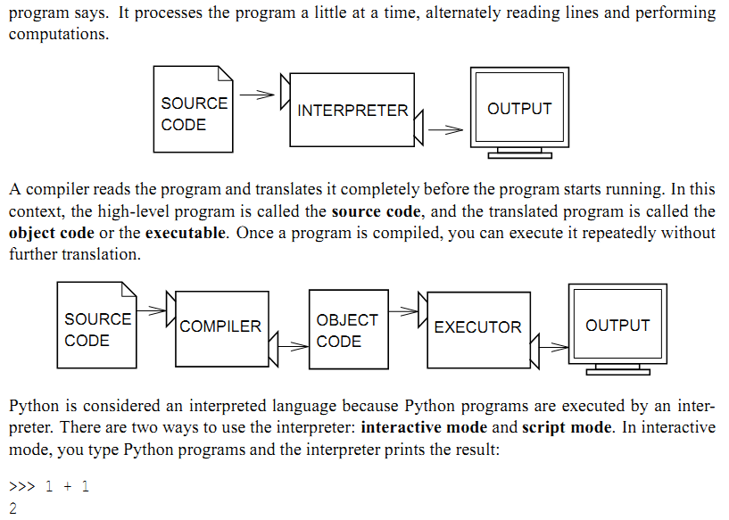

executes - translates - reading - different - processed - languages - easier - programming - interpreter - process