Discussing- Opportunities- Made- Between – Teaches- Screens - Is -Technology - New - Impossible- Most – Were – Made –Has - Time
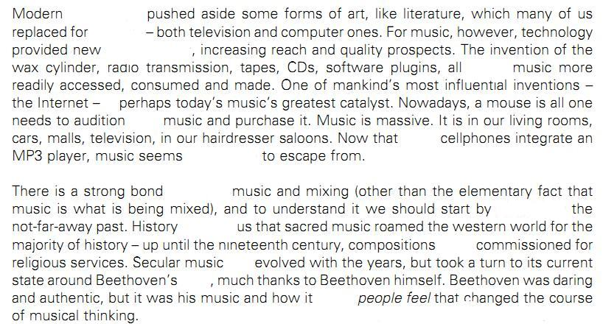

..................................................................................................................................................................................
Discussing- Opportunities- Made- Between – Teaches- Screens - Is -Technology - New - Impossible- Most – Were – Made –Has - Time

