- Listen to the audio, complete the blanks and write what you understand in appropriate Spanish.

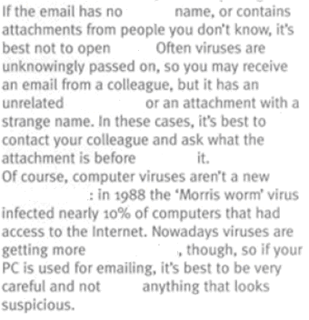

- Identify three words ending in –s and establish their category or write the Spanish equivalent.

- Write the reference for: them (line 16), it (line 21), your (line 30)

