June 15th

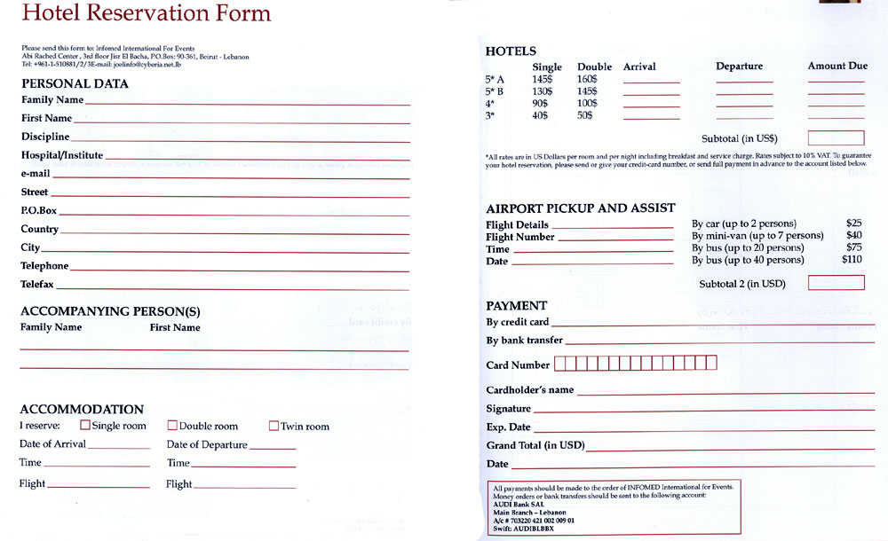

Ring ring

Good afternoon, Four Seasons Hotel, Carlos speaking, can I help you?

Good afternoon, my name is Mr. Perez I’d like to reserve a room.

What type of room would you like?

A double room.

When for? From the 19th to the 28th of August. For the Easter weekend.

Ok let me check.