23rd April Old course of studies

Pages 64, 9, 10, 11, 12, 84, 85

Can I speak to the manager? = I’d like to speak to the manager

Could I speak to the receptionist? = I’d like to speak to the receptionist

I’ll put you through = I’ll connect you

Head office = headquarter

Queen size bed 1.40 mts. King size 1.90/2 mts

Types of rooms: 1. Family room/ connected or adjoining room 2. Double room

3. dormitory, 4. Single 5. En suite room

Answer the phone: greet, give the name of the hotel, give your name, offer help

Ask for name, ask when the reservation is for, ask how many nights is the reservation for

Give the price of the room, ask for a credit card number

SIMPLE PRESENT

VERB TO BE

My name is…../ what is your name? / I am not a student

Speak/ open and close/ get up/ work / study….

I live in Bernal. Do you live in Quilmes? No, we don’t live here.

My friend lives in Quilmes. Does your mother work? No, the university does not offer the medicine career.

THE TIME:

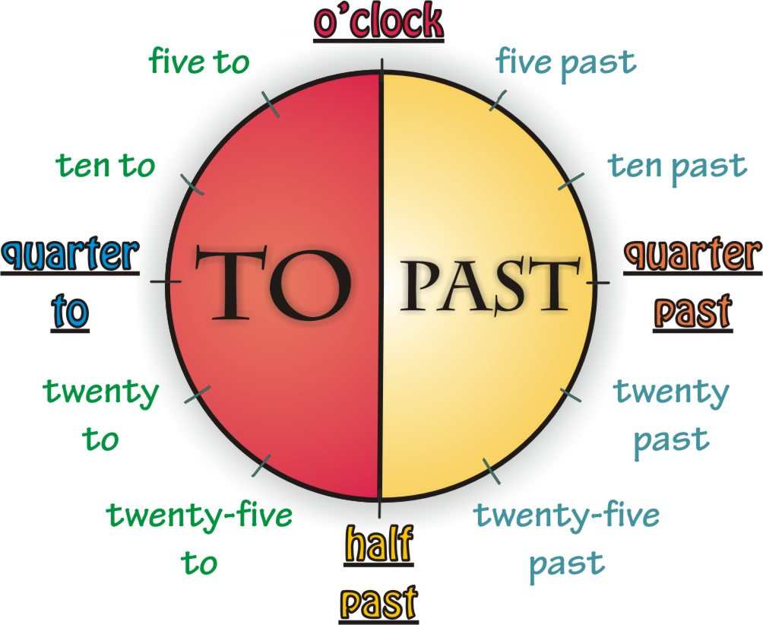

IT’S ONE O’CLOCK AM/PM

*It’s one o’clock*

8:30 CLASSES START AT HALF PAST EIGHT AM

Classes start at eight, thirty

10:05 IT’S FIVE PAST TEN

It’s ten, five

10:40 IT’S TWENTY TO ELEVEN

It’s ten, forty

<http://www.englishexercises.org/makeagame/viewgame.asp?id=8790>

<https://www.ego4u.com/en/cram-up/vocabulary/time/exercises>

Do you serve dinner? No, we don’t

Do you speak English? Yes, we / I do

Do you have a single room for tonight? No, we don’t

Does the waiter/watress speak French? Yes, he does/she does.

Does the hotel have a sauna? No it doesn’t

Does the bar open at six? Yes it does.

It costs… How much does a single room cost?

How much is a double room?

What time does the bar open? / What time do you open the bar?

It opens at 7 o’clock / we open it at….

<http://www.englishexercises.org/makeagame/viewgame.asp?id=3443>

What time do you wake up/ get up? I usually wake up at….and get up immediately/ It depends on the day…..at the weekend I get up at ….when I work

What time do you have breakfast? I usually have breakfast at…./ I don’t have breakfast/ I never have breakfast

What time do you leave your home?

How long do you have for breakfast?/ to have breakfast?

How do you travel to university? By bus, train, car, pay car, taxi, bike, boat, motorbike, on foot/ on skate or rollers

First I take the train and then I catch a bus. I drive my car.

What time do you have lunch?

What time do you go home?

What do you do in the evening/the morning/ summer/ June?

every day I leave my home at 7:15 and go to the university.

Brunch/ tea/ dinner=supper/ snack