**India Deployed Heavy Weight T-90 Tanks Not For War But For Threatening China: Know How**

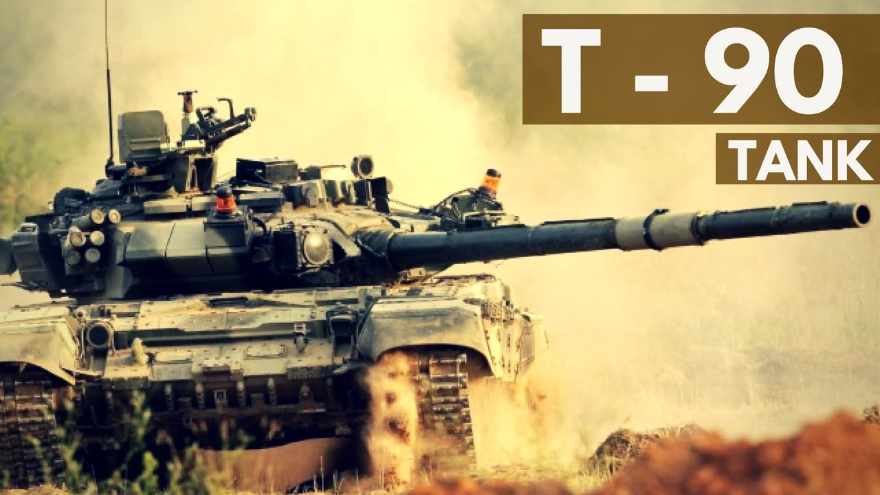

The border tensions escalating between India and China along the **Line of Actual Control (LAC)**, especially after the Galwan valley face-off, has led to the positioning of tanks, artilleries, fighter jets, drones and a massive number of troops by both the countries in the eastern Ladakh region.

India has deployed their Russian made heavyweight T-90 tanks in the eastern Ladakh. On the other hand, China has brought their lightweight Type 15 tanks which are considered to be much lighter than the Indian T-90 tanks.

For your knowledge, Ladakh is one of the toughest places in the world for the tanks to operate because of its unfavourable geographical and weather conditions. The breathing issue due to the thin air and the temperature that sometimes rises to 50 degrees, as said by one of the Indian Army personnel, makes Ladakh a cruel place for operating tanks, especially the heavy ones.

As discussed earlier, India has deployed their heavy-weight T-90 tanks also known as “**Bhisma Tanks**” and the Chinese People’s Liberation Army (PLA) has positioned their light-weight Type 15 tanks. Clearly, the Chinese’s Type 15 tanks being light in weight has a navigational advantage. The Type 15 tanks will find it much easier to navigate in the tough terrain of the Himalayan regions when compared to Indian side T-90 tanks.

The above facts are pinching the minds of the defence experts and personnel around the world to think of the actual reason for placing the heavy-weight T-90 tanks by the Indian Army force. As of now, A US expert named **Arzan Tarapore** has already made a sensible statement on it. According to him, India has placed their T-90 tanks not for defending, but to threaten the Chinese PLA.

Arzan Tarapore is a non-resident fellow at National Bureau of Asian Research (NBR) and the actual statement made by him is, “*They (T-90s) are not there to defend Indian territory but to threaten Chinese territory*”.

Seeing the Chinese PLA deploying their lightweight Type 15 tanks in Ladakh, the requirement for the lightweight tanks by the Indian Army has now become necessary. According to the sources, the Modi government has approved the procurement of lightweight tanks for deploying them in the Ladakh region. At the moment, the requirement of lightweight tanks for the Indian army can only be fulfilled by Russia.